Summary SIAMS Self-Evaluation
Tugby Church of England Primary School


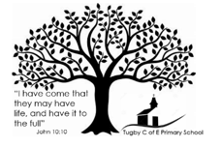
School’s theologically rooted Christian Vision

“I have come that they may have life and have it to the full.” John 10:10

At Tugby our vision inspires pupils and adults to embrace every moment, seek out new experiences and make the most of life. Our Christian values of love, hope, trust, truth, respect and forgiveness are the drivers for our school family living life in all it's fullness. We believe the purpose of education is to nurture and enable all to flourish and succeed in everything they do.

Inspection Conversations: Context
Who are we?  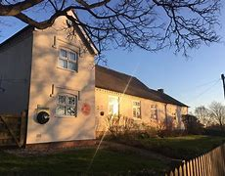  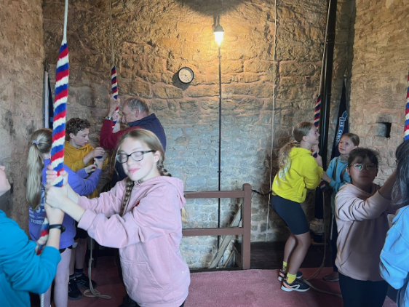 | “We are a small but mighty, super kind and friendly school. We are a family; we work as a team and welcome newcomers” staff quote  Tugby C of E Primary School is a small but inclusive school situated in rural Leicestershire, where farming remains an important part of the local economy. Tugby is part of the Diocese of Leicester and the RISE Multi-Academy Trust (formerly Diocese of Leicester Academy Trust).  There are currently 43 children on roll and the school consists of three mixed age classes. EYFS and Key Stage 1 in Brooks House, Years 3 and 4 in Garden House and Years 5 and 6 in Oak Class. There are three children eligible for pupil premium and there are nine children on the SEND register (20.9%). One of these pupils has an EHCP and another receives top up funding. One pupil within the school has English as an additional language.  The majority of families within our school are white British and the percentage of disadvantaged children is low. The school has very strong links with the local C of E Church and an active governing body which is supportive of the school’s ethos and values.  We always try to be at the heart of village events, no matter how big or small. In return the village is a strong supporter of the school, from our church wardens teaching the children how to ring the bells to the parish council supporting our Summer Fair.
What are we doing here?  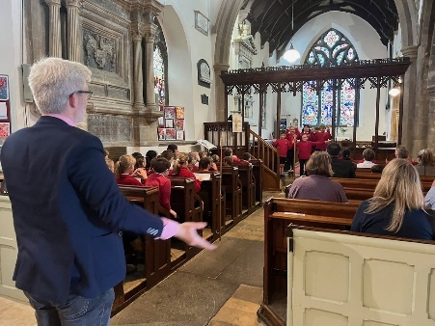  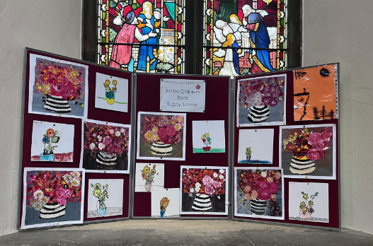 | “The school has been part of the community, working closely with the village for over 175 years!” staff quote  Tugby Primary School was founded in 1841 as a (voluntary controlled) Church of England Primary School. We welcome children of all or no faith and have very close links with Leicester Diocese, Launde Abbey, Billesdon Chapel as well as our local church. We work together with each of these to support all pupils and staff to promote mental health and wellbeing within our local community. We regularly take part in village events with the support of our PFA, we perform a carol concert for the community in the local village hall, run stalls at the village fete and run a half termly service in the church for all to attend.  Our role is to provide a broad and balanced education enabling children to flourish and succeed within the Church of England’s vision for education.  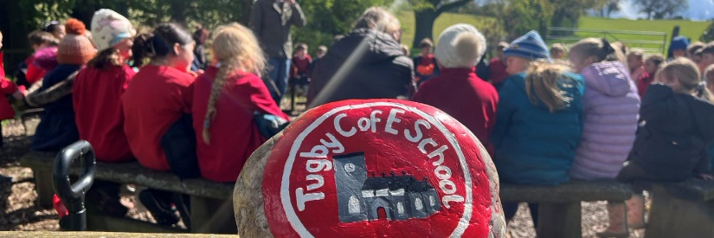  With the love of God, children, staff and families with or without faith and belief are welcomed and celebrated. Our Christian values of love, respect, hope, truth, forgiveness and trust allow no social or cultural divide so that all can flourish and succeed. All can participate, all can enjoy, all can achieve.

Inspection Questions (IQ)

How then shall we live? (This information is key to enabling inspectors to make evidence-based judgements.)

Inspection Question (IQ) | Impact of provision and sources of evidence
- How does the school’s theologically rooted Christian vision enable people to flourish?  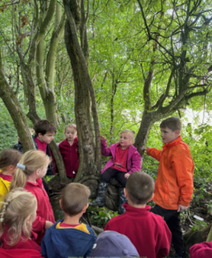  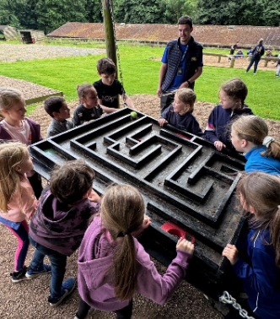   | “I have come that they may have life, and have it to the full.” John 10:10  “We aim to inspire and engage, a place where everyone is equal and respected. We offer more than an education based on the curriculum and encourage everyone to be the best they can be.” staff quote  At Tugby our vision inspires both pupils and adults to embrace every moment, seek out new experiences and make the most of life. To help achieve this we aim to give everyone varied experiences and the opportunity to try new things.  Each half term our staff are offered a chance to participate in an Unwind Staff Retreat at Launde Abbey led by Reverend Johnathan who also offers support for staff well-being in school.  The school staff work hard to engage to with all parents to enable pupils to flourish – staff are present on the playground daily, have regular communication through Class Dojo, weekly newsletters and daily reading records.  We run weekly Forest School sessions in a local private woodland with a focus on developing the children’s confidence and ability to work cooperatively together. The children are also encouraged participate in local sporting events run by the Rutland Schools Partnership, competing and training with and against other schools in the local area. We have been the Small School Champions for the last two years.  The children gain new experiences through our school trips, from learning about lambing and how to reflect in Launde Abbey to pushing themselves out of their comfort zone on our residential. They are also encouraged to perform throughout the year, leading services in the church and taking part in the end of year school production.  We know our vision is having an impact because children from Tugby are confident and well-rounded individuals, staff are happy and pull together as a team. This has been highlighted both by the local secondary school always praises children from Tugby for being polite, thoughtful children who engage in activities and want to learn, and parents who appreciate all that the school does to support their children’s efforts. They praise the family feel of the school and the depth at which all staff know the children.  As a Church of England Primary School, it is our aim that our school and every member of our school community feels valued and respected, that each person is treated fairly with a fully inclusive philosophy and a clear sense of belonging. We strive to provide an education of the highest quality, encouraging and promoting our Christian Values.
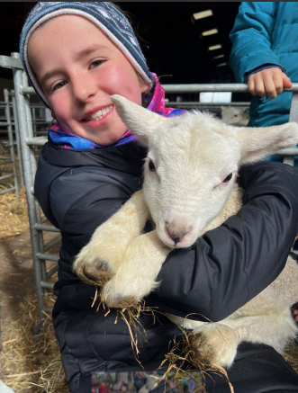  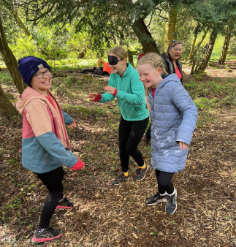  - How does the curriculum reflect the school’s theologically rooted Christian vision?  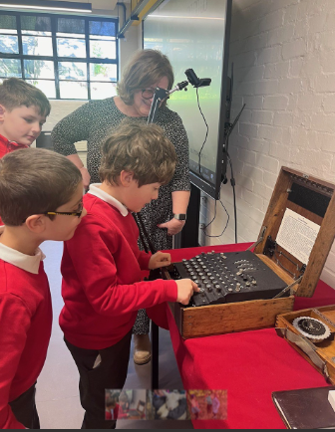  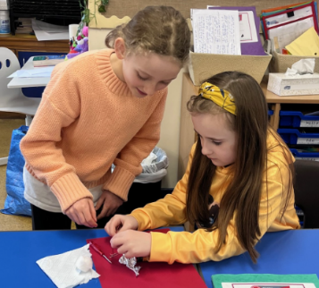 | “We see joy on the children’s faces throughout the school day when they are learning and feel proud of themselves.’ staff quote  Leaders have high expectations of pupils. Pupils, staff and parents work in harmony to enable pupils to achieve well. Pupils enjoy coming to school. Ofsted 2020  Respect for others grows from understanding; understanding that everyone is different, and diversity is to be celebrated and not feared. We provide pupils with windows into others’ lives as well as mirroring their own and nurturing individual talents.  The school’s curriculum has been designed, with the support of RISE, to meet the needs of all children, ensuring progress, high standards and challenges at all levels – for the most able, the disadvantaged and the vulnerable. It ensures that pupils know and remember more enabling all pupils to flourish and succeed and live life to the full.  All staff understand the importance, not only of high academic achievement, but also of developing ‘the whole child’. Every child is expected to meet his or her full potential, vulnerable pupils are given appropriate support, scaffolding and encouragement. Intervention strategies are used when needed to support the children in making progress. Children carry out peer to peer discussion and assessment as part of their learning and use this to support each other and improve their work.  Children throughout the school are used to discussing ethical issues and diversity as part of their everyday learning, for example our PSHE curriculum portrays blended families, and our reading spine includes characters from a range of backgrounds as do our library books. In RE we ensure that we recognise all religions reflected locally in our society.  The school’s vision links to the high expectations for all pupils and the support and inclusivity it provides. The school has agreed a definition of spirituality that is understood by all, and this means opportunities for spiritual development are growing and being nurtured.  We promote and celebrate the children’s personal development throughout the year by taking part in educational visits and sporting events. As part of the Rise Pupil Charter our academy puts on several events throughout the year, including a choral event for year 4s, camping under the stars for year 5 and growing vegetables in year 1.  Children grow and develop through the responsibilities given to them in class and around school – our Christian Ethos Team, School Council, Sports Leaders and roles and responsibilities within each class. In year 6 children take on the role of House Captains, running House meetings and leading their houses in team events throughout the school year. We also collect food for a local charity helping the children to develop an understanding for those less fortunate than us.  Pupils at Tugby are given the opportunity to learn to play the piano, flute, brass, recorder or have singing lessons during their time at our school. They also have the opportunity to develop their own personal safety with all pupils in Year 5/6 learning how to ride a bike safely out in the community through a two level Bikeability course, whole school first aid days in classes and kS2 taking part in swimming lessons to learn about water safety.  As a school, we offer support for our children in year 6 to enable their readiness for the next phase of education and help them to make this transition successfully.
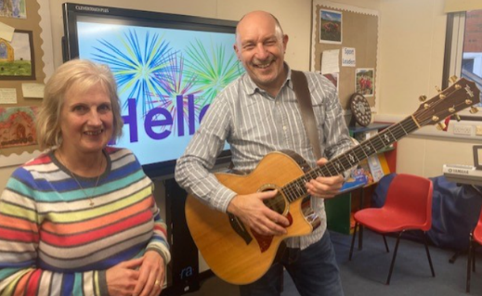  - How is collective worship enabling pupils and adults to flourish spiritually?  The Billesdon Chapel Team  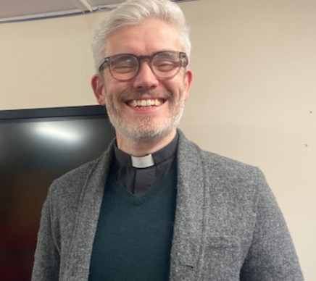  Reverend Johnathan  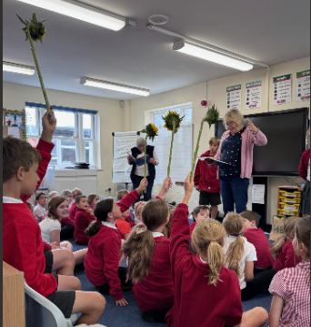  Open the Book | “We see peace, love, joy, prayer, faith and hope on a daily basis throughout the school.” staff quote  Collective Worship is a time to see the world beyond ourselves and recognise our responsibility to serve God through helping others. It is a time of reflection and spirituality; a time for children and adults to come together, be thankful, offer support, share hope and joy.  Our collective worship is predominantly Anglican, including greetings, prayers and hymns. Prayers are chosen or written by our Christian Ethos team, with the opportunity for all children to write prayers if they would like to. Our collective worship is based on our Trust’s overview, with a weekly theme linked to a story which we share with the children on a Monday. On Thursdays we use Picture News to share how events throughout the world impact the lives of others ensuring our children are experiencing a world view during this time.  Pupils attend daily acts of collective worship and regardless of religious belief take time to pause and reflect during religious prayer. All year groups are involved with leading a church service each year with the support of Reverend Johnathan. Before the service Reverend Johnathan will come into school and spend time with each class, discussing the theme of their service, writing prayers and choosing an appropriate hymn. At Christmas our KS1 and EYFS children lead our annual nativity service and Years 3 and 4 lead the Easter performance.  We are extremely lucky to have not only our local clergy but also the Billesdon Chapel Centre and the Open the Book team who come in to lead collective worship either in the school or in the church. Parents are invited to join us in the church for worship and are also informed of our collective worship themes in our weekly newsletter.  Our trust supports the spiritual development of our school through the RE network and provision of collective worship resources. All teachers lead collective worship on a rota basis and there is the opportunity for pupils and adults to attend church services and collaborative events, supporting a range of charities as chosen by both children and staff ensuring that mental health and wellbeing is at the forefront in all that we do.  On Fridays we celebrate the children’s achievements, enabling them to feel proud of their week in school, reflect on what has gone well and show support and encouragement for the achievements of their friends.  Within school children and staff have the opportunity for outdoor reflection in our prayer garden, also during forest school sessions the children are offered the opportunity to quietly reflect on their day or activity.  Reverend Johnathan also supports the staff wellbeing within the school, by leading staff retreats at Launde Abbey and providing teachers with time out of class by taking the children for spirituality sessions once a term. The children will share their experiences with Reverend Johnathan during the next collective worship reflecting on the different activities they have taken part in.
- How does the school’s theologically rooted Christian vision create a culture in which pupils and adults are treated well?  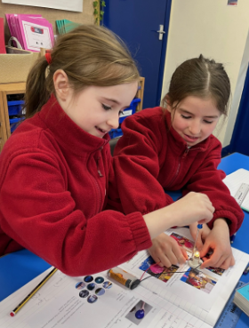  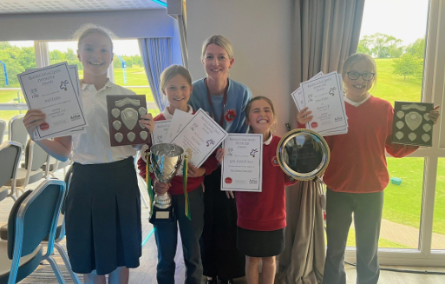  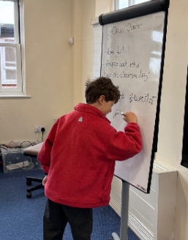  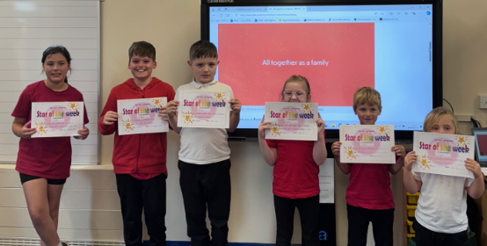 | ‘Our school values are; love, hope, trust, truth, hope, respect and forgiveness. We connect with our community through church services, carol concerts, musical productions and village events sharing our values in all we do’ staff quote  Pupils are happy and relationships throughout this school are strong. The school’s ‘character programme’ helps pupils to become well-rounded citizens. Pupils are respectful and friendly towards each other, staff and visitors. Ofsted Report 2020  To ensure our vision of enabling every child to live life to the full we try to instil our school values into every pupil and staff member.  Our values are;  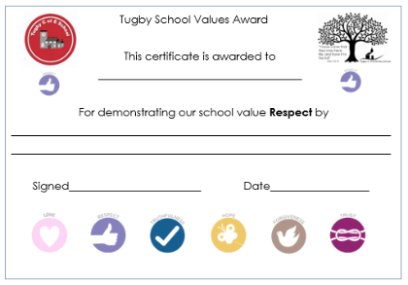  We all try to demonstrate these values in the way that we interact with each other. In school this means that children are kind to each other and show each other respect. We celebrate each other’s achievements, give each other support and encouragement when needed and listen to each other with respect, ensuring we value everyone’s ideas. During our celebration assembly certificates are awarded to children who demonstrate these values throughout the week.  Our behaviour policy focuses on positive behaviour and outcomes, children work individually and as a class to gain rewards, this helps them develop an understanding of their behaviour and consequences of their actions. For example, the class lining up award.  Children and parents are positive about their experiences of the school. Children say that they feel safe and cared for in school, behaviour is good, and we all look out for each other. Governors talk to children to get their views and parents complete an annual questionnaire with the overall responses being positive.  Pupils behave well. They know how to learn and take pride in doing so. Ofsted 2020  Because our vision is to ensure that everyone can live life to the full, we work hard to provide support for vulnerable children and adults within our school, making sure adults know where they can go to get support if needed and providing wrap around care for pupils. We ensure that vulnerable children are offered the same opportunities as everyone else and are given support to attend activities. We have a family feel to the school and all adults and children know they will be listened to if support is needed.
  Love | Thinking about the needs of others and not just myself
  Hope | Building a positive mind-set which looks forward to the future
  Truth | I know that it is important for everyone to tell the truth
  Trust | Building friendships and community, based on trust
  Respect | Valuing each other through learning about differences
  Forgiveness | Saying sorry when we get things wrong
- How does the school’s theologically rooted Christian vision create an active culture of justice and responsibility?  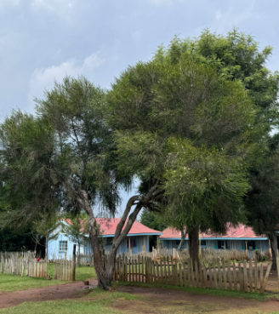  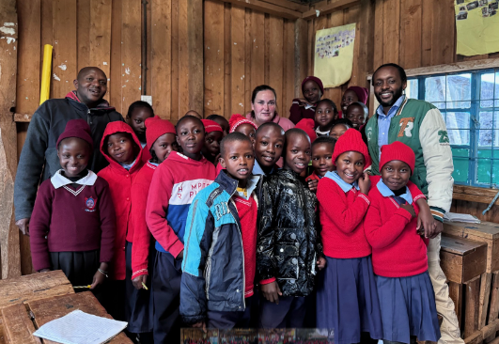  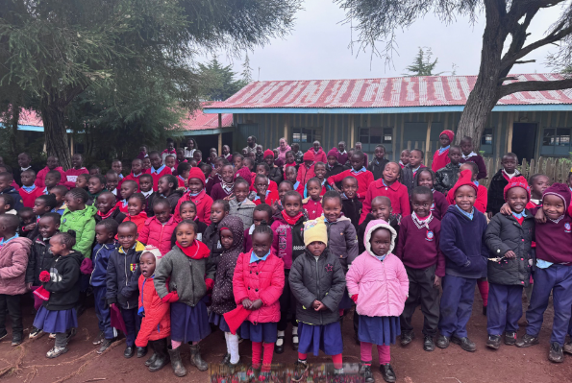 | ‘We are a long-standing village school and a pillar of the community’ staff quote  The school’s Christian vision and values enables the children to create an active culture of justice and responsibility. Children develop emotional literacy and the ability to make informed and appropriate choices, these are rooted in their personal and religious beliefs, enabling them to become agents for change.  Our curriculum includes a range of topics which develop global understanding and a sense of justice, including ‘Civil Rights’ and ‘Remembrance’ in history and ‘Migration’ and ‘Renewable Energy’ in geography. Weekly themes for collective worship include Picture News Worship which enhances pupil ability to look out and learn about the wider world.  We are currently developing links with Kahia Academy in Kenya. One of our staff members recently visited the school based in the Donduri region of Kenya and spent time in class with the children. Whilst there, the children of Kahia Academy wrote letters to the pupils at Tugby, and we have begun a letter exchange with them. We have collected resources and made a shoe box for each child in Kenya containing writing supplies, a pencil, exercise book and a rubber, to send with our next letters as these are not provided for children in Kenyan schools and many families struggle to afford them. We are hoping this link will develop an understanding of life for children in another country, the different challenges they face and hopefully foster some friendships for the future.  British Values are demonstrated at Tugby on a daily basis with Democracy seen during House Meetings, debates in class and in parent and pupil surveys. During these debates, children have shown their developing understanding and appreciation of cultural influences, diversity, a range of world faiths that are essential elements that they will encounter in modern Britain. Rule of Law is seen in our behaviour policy, in the Rise behaviour policy and in our PSHE curriculum. Tolerance, Individual Liberty and Mutual Respect all being discussed within Collective Worship, PSHE and in our RE curriculum.  We see pupil led action within the school during School Council meetings, where children discuss what they would like to see happen in school and in the local community. We also have a project at the end of the year where the KS2 children make something to sell to raise money for a charity of their choice. We have a culture within school that encourages children to come and share their ideas or worries, this means that they are often at the forefront of change within school.  Annual charity work includes joining schools from across the Trust to fundraise for Rainbows, our local children’s hospice, through a whole school sponsored ‘Santa Run’. This always a wonderful day, during which all pupils and staff come together on our local village green, with the villagers coming out to support us. The children and their families donate tinned or dried goods to the church for the Harvest festival which is donated to the One Roof Charity in Leicester.  Safeguarding is taken seriously within school, there is a cohesive and collective approach for keeping everyone in the school safe. Time and effort is put in to develop the knowledge and skills of each staff member and they are appropriately supported, feel valued, heard and have the opportunity to flourish.
- Is the religious education curriculum effective (with reference to the expectations set out in the Church of England’s Statement of Entitlement for Religious Education)?  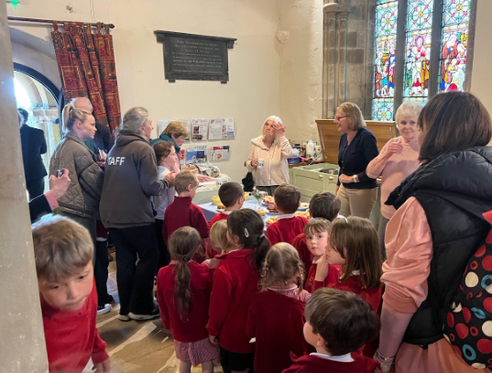 | ‘We have a vision based on faith for a caring community with respect and love for all’ staff quote  At Tugby School the RE provision that our children receive reflects the Church of England statement of entitlement. Working from the Trust’s overview we follow the NATRE planning, which combines the Local Agreed Syllabus and Understanding Christianity units, we provide our children with a balanced approach that includes a comprehensive understanding of different religious traditions, beliefs, practices and ethical teachings, with Christianity at the forefront of RE learning across our school.  Teachers are provided with planning and resources from the agreed syllabus to enable them to deliver high quality learning, which is accurate and well sequenced to build on prior learning. RE is delivered through weekly age-appropriate lessons and Collective Worship to cover, Christianity, Hinduism, Judaism, Islam and Humanism as well as non-religious beliefs and anti-racism. We have added and adapted the anti-racism unit for years 5 and 6 to meet the needs of our children and community. Using resources from NATRE also enhances teachers’ knowledge and delivery. Pupils know and remember more of their learning in RE due to the accessible and engaging RE curriculum which challenges them through an exploration of core concepts and questions.  Our curriculum intentionally readies the children to live life in all it’s fullness and helps them to prepare for the opportunities, responsibilities and experiences of a multicultural modern Britain.

